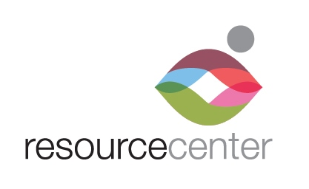

EMPLOYMENT

OPPORTUNITY

Nurse Practitioner/Physician Assistant:

Seeking licensed and experienced NP/PA to fill full-time position at Resource Center’s Nelson-Tebedo Clinic and LGBTQ Health & Wellness Clinic in Dallas, TX.

NP/PA will provide in-person and telehealth medical care and prescription services for clients/patients meeting the Center’s eligibility requirements. Services will be completed in a clinic setting with access to a nurse and patient navigator under the supervision of a licensed physician. In-person care will be minimal during pandemic.

Schedule:
- 20 hrs. per week, M-F, 9 a.m. – 1 p.m. providing in-person and telehealth services including medical care and prescription services for Pre-exposure Prophylaxis (PrEP) and Hormone Replacement Therapy at Resource Center’s Nelson-Tebedo Clinic.

- 20 hours per week, M-F, 2 p.m. – 6 p.m. providing in-person and telehealth services including medical care and prescription services for LGBTQ patients at Resource Center’s LGBTQ Health and Wellness Center.

Requirements:
- Prefer candidate with experience treating and managing care of a culturally diverse population.
- Prefer candidate with 1-year practicing and working with people living with HIV. Will consider recent graduate
- Education: NP or PA
- Current and valid Texas medical license required
- Experience with Ryan White funded services a plus

Full-time position. Salary commensurate with experience. Comprehensive benefits package provided.

Access to reliable transportation and valid DL required. Must be able to pass a background check.

Position reports to Prevention Services Manager and Medical Director.

Position open until filled.

Send resume, cover letter with salary requirements and application to jobs@myresourcecenter.org

