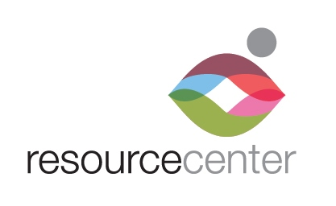

EMPLOYMENT

OPPORTUNITY

Primary Care Medical Assistant:

Medical Assistant position available for Resource Center’s LGBTQ Health program. This position is responsible for providing information, services, and assistance to the Center’s medical and HIV services programs.

Duties and Responsibilities:
- Verifies patient information by interviewing patient, recording medical history, and confirming purpose of visit.
- Prepares patients for history and examination by health provider by performing preliminary physical tests: measuring blood pressure, weight, and temperature; reporting history summary.
- Assists provider with examination, obtaining clinical specimens, performing procedures, performing rapid clinical tests, obtaining EKG, performing flow spirometry.
- Maintains safe, secure, and healthy work environment by establishing and following standards and procedures, complying with legal regulations.
- Maintains client confidentiality and privacy; ensures informed consent.
- Adheres to professional standards, policies and procedures, federal, state, and local requirements.
- Enters medical information into the electronic medical record including scanned documents.
- Provides office support with duties of answering phones, interacting with patients, filing and data entry.
- Maintains medical supplies inventory.
- Other duties deemed necessary by the Medical Director or Office Manager.

Required Qualifications:
- Strong communication, organizational, customer service and problem-solving skills.
- Demonstrated efficiency working with an electronic medical record.
- Graduate of an accredited Medical Assistant Program. Associate degree in Medical Assisting preferred.
- Current CPR certification.
- Respect and demonstrated interest for the LGBTQ community.
- Bilingual in English/Spanish desired.
- Proficiency in MS Office applications (Word, Excel, Outlook) expected.

Hours: Mon-Fri, 2-6 p.m. This is a part-time position and does not include benefits. Compensation $15.40/hr.

Access to reliable transportation and valid DL required. Must be able to pass a background check.

Position reports to Medical Director. Position open until filled.

Send resume, cover letter and application to jobs@myresourcecenter.org

