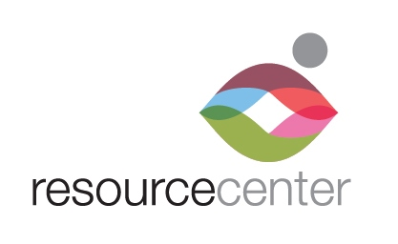

EMPLOYMENT

OPPORTUNITY

Dental Assistant:

Full-time position available for Dental Assistant. The Dental Assistant is responsible for preparing patients for dental treatment and assisting the attending dentist with procedures. This includes providing patient support service, maintaining equipment and other duties as assigned.

Job Responsibilities:
- Assist dental staff (dentists, hygienists, and Dental Coordinator)
- Seat, monitor, and dismiss clients
- Deliver proper post-operative instructions
- Sterilize and disinfect all instruments, equipment and treatment areas and prepare them for the next business day
- Order and maintain supplies, equipment, and laboratory cases needed to provide services
- Expose radiographs for treatment diagnosis
- Stock all rooms with supplies needed to provide services
- Review charts for current blood work, paperwork, referrals, doctor’s notes, etc.
- Pull and file charts
- Perform all duties in accordance with OSHA safety and protection protocols and HIPPA compliance
- Maintain MSDS for OSHA compliance
- Oversee storage, collection, and disposal of medical waste.
- Assist Dental Manager with programmatic growth and facilitate ongoing enhancement of services
- Assist with policies and protocols relating to safety and overall operations
- Any other duties as assigned by the Dental Manager

Skills/Qualifications:
- Current Registered Dental Assistant licensure required; experience preferred
- Strong organizational skills
- Strong interpersonal skills
- Ability to work cooperatively with diverse staff and volunteers
- Ability to work hours as required
- Computer skills as necessary to use dental software
- Spanish language skills preferred
- CPR certified

Physical requirements: No physical restrictions.

Full time position. Competitive salary and comprehensive benefits package is provided.

Access to reliable transportation and valid DL required. Must be able to pass a background check.

Position reports to Dental Manager. Position open until filled.

Send resume, cover letter and application to jobs@myresourcecenter.org

